CALL FOR SUBMISSIONS:
Community engagement for inclusive rural transformation and gender equality
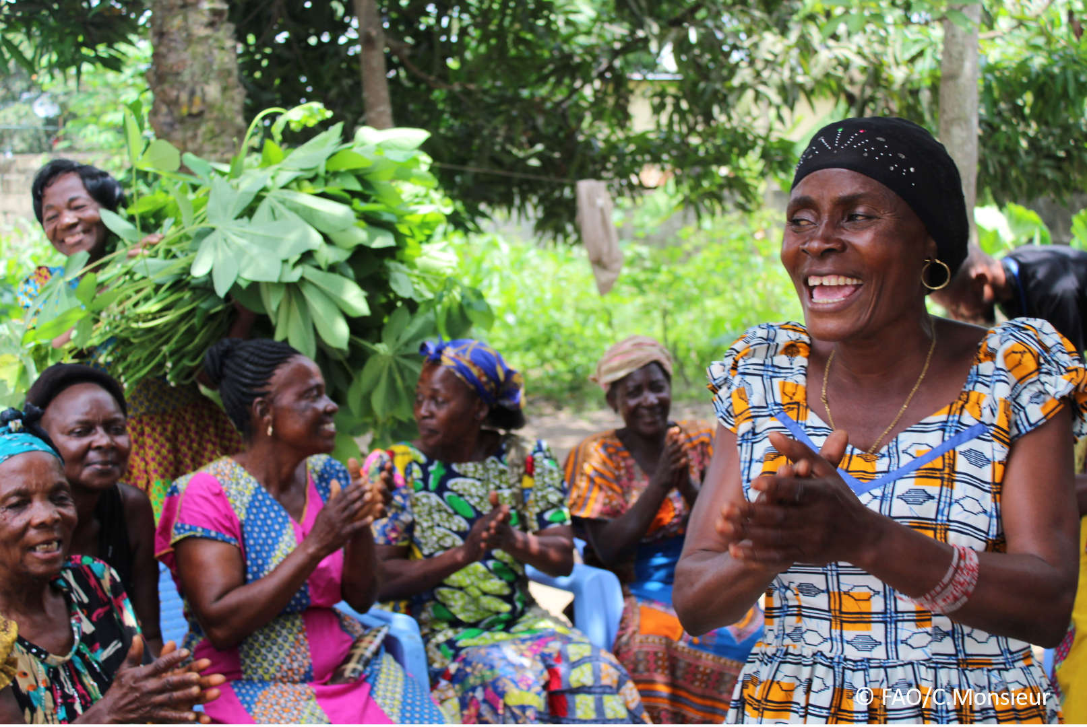
The objective of this call for submissions is to collect good practices, experiences, and lessons learnt on the use of community engagement for inclusive rural transformation and gender equality. The initiative, organized by the Rural Transformation and Gender Equality Division (ESP), seeks to gather insights from a diverse range of contributors, both within FAO and from external stakeholders. Its goal is to share knowledge, foster learning, and guide the scaling up of community engagement and community-led collective action to leave no one behind. The call builds on FAO's past efforts in this area, such as the Community Engagement Days series of webinars.
The call for submissions is open until 27 November 2024.

How to take part in this call for submissions:
To take part in this Call for submissions, please register to the FSN Forum, if you are not yet a member, or “sign in” to your account. Please review the topic note to understand the criteria we are considering for this call. If you wish to learn more about community engagement, you may refer to the background document. Once you have completed this submission template, upload it in the box “Post your contribution” on the call webpage, or, alternatively, send it to fsn-moderator@fao.org.
Please keep the length of submissions limited to 1,500 words and feel also free to attach relevant supporting materials.

Template for submissions

Contact person | Name: Barbara Scettri  Organization/Unit: Plan International  Country: Global  Email address:  Barbara.Scettri@plan-international.org
Name/title of the good practice | Boosting Locally Produced School Meals - The Integrated School Feeding programme (ISFP)
Where is the good practice taking place? (Multiple selection allowed) | ☐ Europe and Central Asia  ☐ Latin America and the Caribbean  ☐ North Africa and Near East  ☒ Sub-Saharan Africa  ☐ Asia and the Pacific  ☐ North America  ☐ Global
Affiliation | ☒ Farmer and producer organizations  ☐ Trade Union  ☒ Informal community-based, farmer-based or self-help group  ☐ Research and academia  ☒ Government  ☐ Local/traditional authorities  ☐ Private Sector  ☐ Civil Society Organization  ☐ Intergovernmental Organization (e.g. UN system, World Bank)  ☐ Resource Partner/Donor  ☐ Other (please specify)
In which sector(s) and context (s) have you used this community engagement good practice? (Multiple selections allowed) | ☒ Education  ☐ Health and Sanitation  ☒ Food production in agrifood systems (please also tick the sub-categories)  ☒ Crop cultivation  ☐ Fisheries and aquaculture production  ☐ Livestock  ☐ Forestry  ☐ Agroforestry  ☐ Horticulture  ☐ Apiculture (beekeeping)  ☐ Agroecology and sustainable farming practices  ☐ Soil and water management  ☐ Other: ____________  ☐ Post-production in agrifood systems (please also tick the sub-categories)  ☐ Processing and value addition  ☐ Marketing and retailing  ☐ Transporting  ☐ Food loss and waste  ☐ Packaging  ☐ Storage  ☐ Distribution  ☐ Other _________  ☒ Gender Equality  ☐ Climate Action  ☐ Citizenship and Governance  ☐ Social Protection  ☐ Humanitarian and protracted crisis  ☐ Conflict resolution, peace and resilience  ☐ Digital innovation  ☐ Other sector (please specify) _________
Who are the financial partners supporting this good practice, if applicable? | Ministry of Basic & Senior Secondary Education of Sierra Leone
- In a few sentences, summarize your community engagement good practice.
Aligned with President Bio's Transforming Education Agenda, the Integrated School Feeding programme (ISFP) has yielded remarkable results. Providing daily meals to 183,347 children (91,375 girls) in six districts in Sierra Leone, ISFP has significantly improved school enrolment rates, attendance, and participation. ISFD has played a crucial role in reducing dropout rates by allowing more students, especially girls, to stay in school and complete their education. It also has eased the financial burden on families, allowing them to allocate resources to other urgent needs. Notably, it has supported women-led cooperatives in improving their capacities to participate in livelihood and market accessibility, supporting the school feeding value chain.
- What problem(s) or challenge(s) does your good practice aim to address through community engagement?
Sierra Leone faces continuous food insecurity, which impacts over half of its population. Almost two million children lack sufficient food, and over one million are at risk of child abuse. The integrated school feeding program (ISFP) contributed to improving educational access and learning outcomes and to improving the supply chain of locally sourced foods, which is a commitment of the government in Sierra Leone. ISFP has provided school meals, promoted gender equality and child/youth protection, and addressed negative social norms.
- Describe your good practice in more detail. Include the main guiding principles, the desired changes or outcomes you aim to achieve (Theory of Change), and the key phases of implementation.
Overall Objective: Improve the realisation of the right to education for children, especially girls in Bo, Moyamba, Port Loko, Kailahun, Bombali, and Western Rural Area (WRA) in Sierra Leone.
Specific Objectives:
- Improve access to education for girls and boys through the provision of food and NFIs
- Reduce short-term hunger for schoolchildren
- Increase availability of school-produced nutritious foods in target schools
- Improve women-led cooperative group’s participation in livelihood and market accessibility in agri-business production and economics
- Improved knowledge of women-led cooperative groups in the school feeding value chain
- Increase procurement of foods and services from female value chain actor
- Improved community engagement, especially on gender equality and inclusion.
- Increase knowledge of gender equality & inclusion, safeguarding, and child/youth protection among community members and target stakeholders.
- Increase usage of community feedback mechanisms

Key phases of implementation
- School environment
- School-going children receive a hot meal each school day for lunch
- Project staff and head teachers establish school gardens
- Increase economic activity
- Local food vendors including women's cooperative groups are contracted to supply food to target schools
- Local suppliers are contracted to transport and house food supplies
- Community engagement
- Project staff train community members including head teachers, mother club representatives, and community focal persons on gender inclusion and safeguarding
- Accountability and feedback mechanisms are established in target communities through a 511 toll-free line and a dedicated online platform.
- Who are the key actors and stakeholders involved in the design and implementation of the good practice, and what are their respective roles? Consider local partners, government, local authorities, community radios, civil society, research, the private sector, etc.
- School children engaged in safeguarding risk assessment. School children are asked to identify the risks they might be exposed to and the possible abusers. They then rank the risks and identify who should be responsible for preventing and/or addressing them. Risks and actions are presented by the students to relevant stakeholders (teachers and head teacher, school management committee, local leaders, etc). A similar exercise is conducted with adults. Both children’s and adult’s recommendations fed into school safeguarding action plans.
- Teachers participated in sessions focussing on safeguarding, gender, and inclusion. The purpose of these sessions is to increase school staff's capacity to identify and address exclusion and discrimination and to promote gender equality and inclusion in their schools. A positive approach creates a conducive and safe learning environment for all learners increasing enrolment and retention, especially for those groups who are most marginalised.
- Women members of female cooperatives got their knowledge and skills supported and, in turn, felt more self-confident about actively participating in their communities.
- How does your intervention ensure inclusivity and equal and meaningful participation within the community?
Describe how your intervention includes and engages different groups within the community. Consider aspects like gender, age, ethnicity, disability status, livelihoods, and other specific conditions (e.g., people living in prolonged crisis, migrants, refugees). Explain how your intervention engages diverse segments of the rural community. Highlight the specific actions or strategies you use to reach these groups. If applicable, mention if your intervention uses specific approaches such as gender-responsive, gender-transformative, intersectionality, or other methods to ensure inclusivity and gender equality.
ISFP recognised the importance of addressing gender disparities to empower girls’ education in Sierra Leone. Through analysing the impact of inadequate food, risky behaviours, and social norms, ISFP is a gender-responsive programme, aligned to the MBSSE Radical Inclusion Policy (Est. 8 April 2021). The programme includes training for teachers, SMC (School Management Committee) members, and district stakeholders across target communities to increase their knowledge of gender-responsive approaches to engaging and protecting children and youth. These efforts aims to enhance gender equality and educational opportunities for those most marginalised, especially girls and women in Sierra Leone.
- By using community engagement, what results and impacts have your good practice achieved?
Please provide specific examples and evidence demonstrating the effectiveness of your intervention, focusing on both qualitative and quantitative outcomes related to livelihoods and well-being improvements.
What sets Sierra Leone's National School Feeding Programme apart is its commitment to sustainability through the Home-Grown School Feeding Programme (HGSFP). By promoting local agricultural production, the programme provides not only nutritious meals but also stimulates community-led economic growth, supporting women-led groups. It creates job opportunities, income generation, and agricultural education initiatives for students and local communities. Through the HGSFP, the programme fosters self-sufficiency, resilience, and the long-term social and economic development of Sierra Leone.
School gardens are set up to integrate food availability in schools and to provide learning spaces where students, boys and girls, can learn about the sustainable production of nutritious food.
School gardens align closely with the Integrated Home-Grown School Feeding (IHGSF) of MBSSE’s National School Feeding Policy (2021), contributing to a more sustainable school feeding programme by providing locally produced food and resources.
- Among these results, has the good practice led to improvements in terms of gender equality, women’s empowerment, and/or social inclusion?
Describe the behavioral changes in terms of gender that the good practice promotes, emphasizing agency, leadership, and participation in local governance. Include efforts to challenge discriminatory norms and unequal power dynamics. Highlight also how the intervention has supported the well-being (including psychological resilience) of marginalized groups and enhanced their inclusion and participation in decision-making processes.
Increased participation of female-led agribusiness in the supply of locally produced food for school feeding is an outcome for ISFP that aligns with the IHGSF of the National School Feeding Policy (2021). Female-led agribusinesses are specifically targeted by the programme to support them in expanding their networks and strengthening their capacities. A specific training package was developed, including topics such as food packaging, food hygiene, procurement procedures, and how to operate a business.
- What key challenges did you encounter while implementing the community engagement activities, and how did you address them?
Include any resistance from communities, pushback, or issues related to unequal power dynamics, if applicable.
- What are the key lesson learned from your community engagement good practice?
- Has this practice been replicated in the same context or in different contexts?
What are the required conditions to replicate and adapt the practice in another context/geographical area?
The programme started in 2021 and has now reached its 4th iteration, gradually increasing the number of participants and target communities.
- How sustainable are the results achieved by this good practice?
Describe the key elements that need to be in place to make the initiative sustainable, including enabling environment (legal and policy frameworks and institutions), local ownership, accountability, etc.
Strengthening community self-sufficiency and tackling gender inequality and exclusion promotes local ownership and, in turn, sustainability.
- Based on the conversations FAO held during the Community Engagement days, a definition of community engagement for empowerment was proposed:

“Community engagement for empowerment and community-led collective action can be defined as an inclusive and participatory process that enables community members to become active agents of change in decisions affecting their lives, health, and environment. This process develops their capacity to achieve sustainable outcomes for improved rural livelihoods. Embracing a rights-based approach, it prioritizes the agency and participation of all community members, regardless of gender identity, sexual orientation, age, ethnicity, caste, socioeconomic status, political affiliation, migration status, or ability/disability. Indeed, inclusive approaches recognize the complexities of overlapping marginalization and discrimination that can exclude different community members from decision-making processes and implement strategies to foster their participation, agency and empowerment.”

We invite you to contribute to this definition. What would you add or change? Please share your thoughts, suggestions, and any additional elements you believe are crucial for a comprehensive understanding of community engagement approaches aimed at community-led collective action for inclusive rural transformation, people’s empowerment and gender equality.
\
- Based on your experience, what gaps or areas for improvement still need to be addressed in the field of community engagement?
- What do you think is FAO's role in the field of community engagement? How can FAO support and enhance interventions like yours, if applicable? Consider aspects such as policy advocacy, capacity development, funding, technical assistance, knowledge production and sharing, and fostering partnerships.

Link(s) to specific references about your good practice (e.g. reports, communication products, videos, articles) | Please include attachment(s) or add here link(s) to documents/videos/podcasts/other with specific references.  Integrated school feeding programme | Plan International Sierra Leone

The call for submissions is directly aligned with the thematic components of collective action within FAO's Programme Priority Areas (PPAs), specifically Better Life 1 (Gender Equality and Rural Women’s Empowerment), Better Life 2 (Inclusive Rural Transformation) and Better Life 3 (Agriculture and Food Emergencies).

